SPRING-40 – Swagger Documentation

Dependency:

<dependency>  
 <groupId>io.springfox</groupId>  
 <artifactId>springfox-boot-starter</artifactId>  
 <version>3.0.0</version>  
</dependency>

Config file:

@Configuration  
@EnableSwagger2  
public class SpringFoxConfig {  
 @Bean  
 public Docket api() {  
 return new Docket(DocumentationType.*SWAGGER_2*)  
 .select()  
 .apis(RequestHandlerSelectors.*any*())  
 .paths(PathSelectors.*any*())  
 .build();  
 }  
}

Beans introduced:

@Bean  
public WebMvcEndpointHandlerMapping webEndpointServletHandlerMapping(WebEndpointsSupplier webEndpointsSupplier, ServletEndpointsSupplier servletEndpointsSupplier, ControllerEndpointsSupplier controllerEndpointsSupplier, EndpointMediaTypes endpointMediaTypes, CorsEndpointProperties corsProperties, WebEndpointProperties webEndpointProperties, Environment environment) {  
 List<ExposableEndpoint<?>> allEndpoints = new ArrayList();  
 Collection<ExposableWebEndpoint> webEndpoints = webEndpointsSupplier.getEndpoints();  
 allEndpoints.addAll(webEndpoints);  
 allEndpoints.addAll(servletEndpointsSupplier.getEndpoints());  
 allEndpoints.addAll(controllerEndpointsSupplier.getEndpoints());  
 String basePath = webEndpointProperties.getBasePath();  
 EndpointMapping endpointMapping = new EndpointMapping(basePath);  
 boolean shouldRegisterLinksMapping = this.shouldRegisterLinksMapping(webEndpointProperties, environment, basePath);  
 return new WebMvcEndpointHandlerMapping(endpointMapping, webEndpoints, endpointMediaTypes, corsProperties.toCorsConfiguration(), new EndpointLinksResolver(allEndpoints, basePath), shouldRegisterLinksMapping, null);  
}  
  
  
private boolean shouldRegisterLinksMapping(WebEndpointProperties webEndpointProperties, Environment environment, String basePath) {  
 return webEndpointProperties.getDiscovery().isEnabled() && (StringUtils.*hasText*(basePath) || ManagementPortType.*get*(environment).equals(ManagementPortType.*DIFFERENT*));  
}

Properties file:

spring.mvc.pathmatch.matching-strategy=ant_path_matcher

UI:

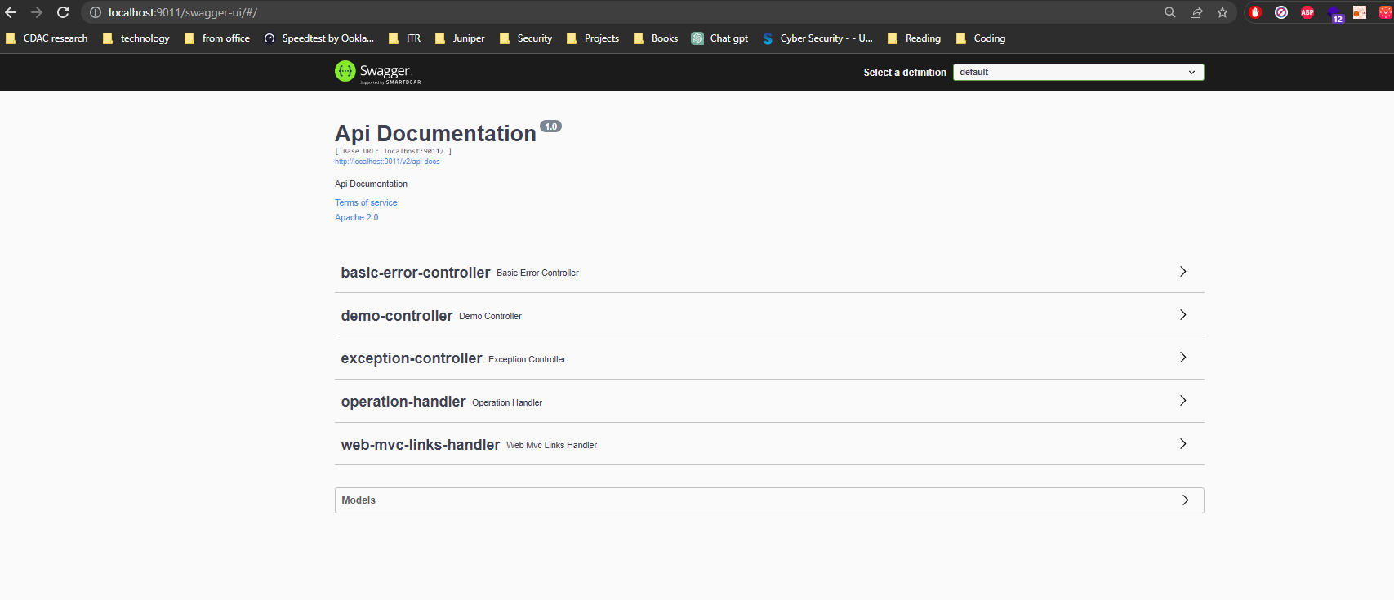

Annotations:

1. @ApiOperation: Endpoint description:

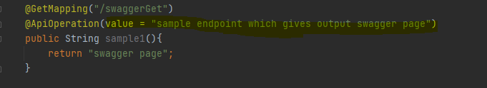

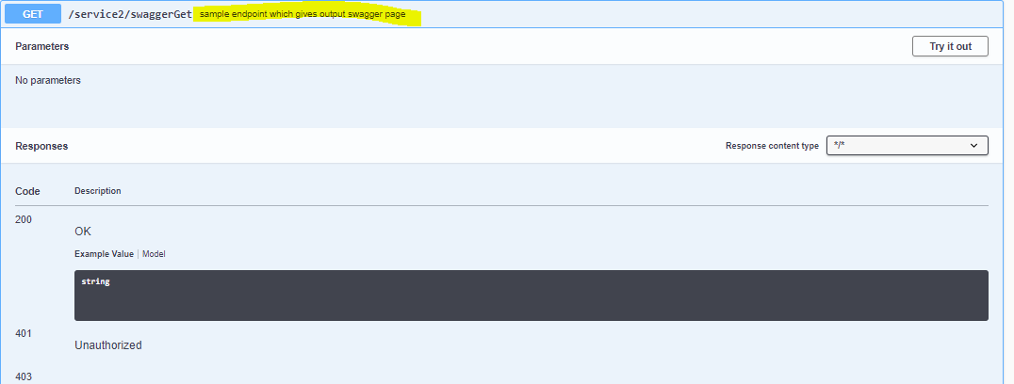

1. @ApiParam: parameter description:

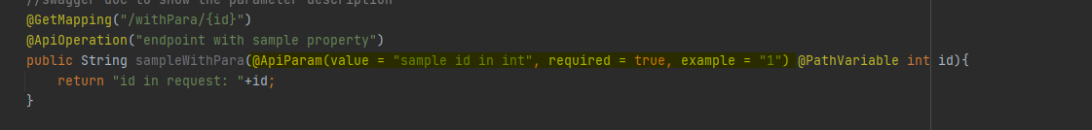

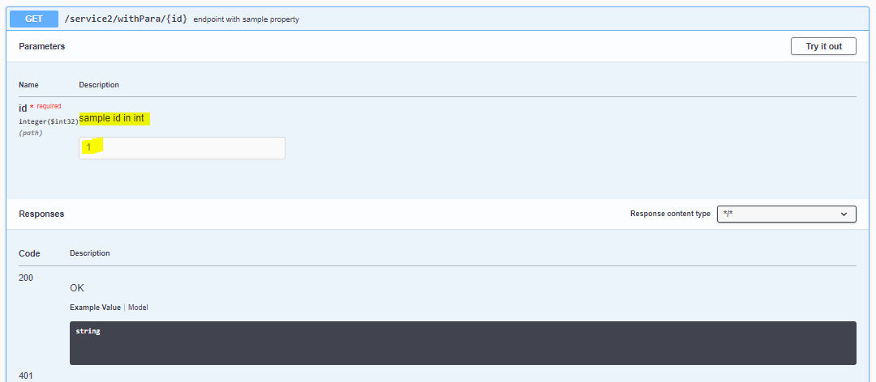

1. @ApiModel: object description:

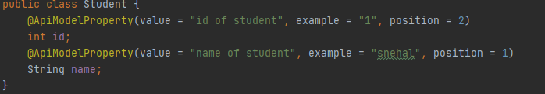

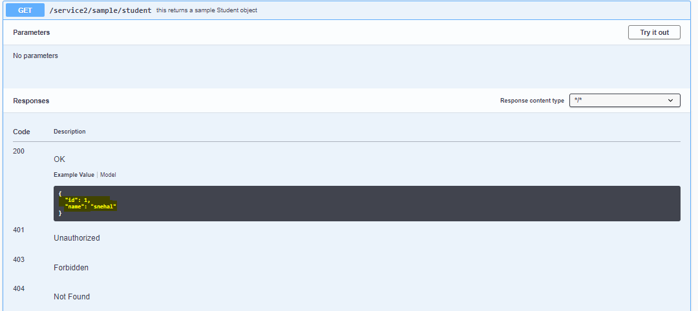

1. @ApiResponses:

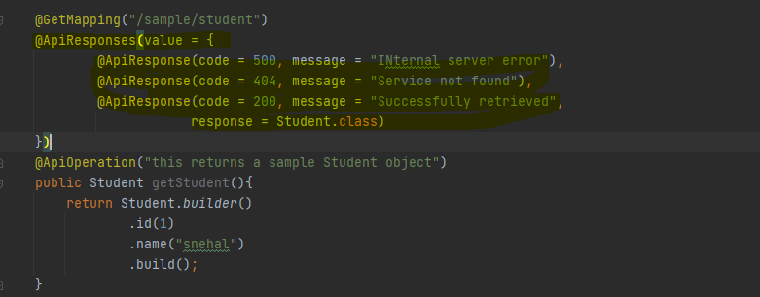

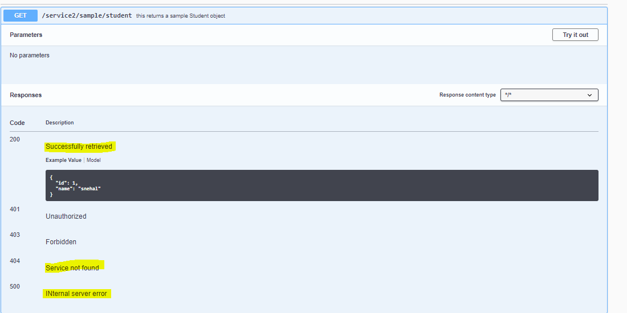

1. @ApiModel and @ApiProperty:

